|  |
| --- |
| eInvoicing communication kit  June 2022 |

Contents

How to use this kit 4

Versions 4

eInvoicing explained 5

Benefits of eInvoicing 6

How eInvoicing works 6

The ATO’s role 7

How to get started with eInvoicing 8

If you’re already using software to create, send or receive invoices 8

If your software doesn’t have eInvoicing capability 8

If you don’t use software for your invoicing 8

What are the costs involved? 9

Frequently asked questions (FAQs) 10

Sample articles 14

eInvoicing can save you time and money 14

eInvoicing – the safe and secure way to do business 14

eInvoicing – the new way to invoice 14

Sample onboarding email 16

Social media messages 17

Images 18

© Australian Taxation Office for the Commonwealth of Australia

You are free to copy, adapt, modify, transmit and distribute this material as you wish (but not in any way that suggests the ATO or the Commonwealth endorses you or any of your services or products).

**This is a general summary only.** For more information visit [ato.gov.au/eInvoicing](http://www.ato.gov.au/eInvoicing)

# How to use this kit

The Australian Taxation Office (ATO) has developed this kit as a resource for intermediaries, advisers and businesses to assist in engaging and communicating with their clients and trading partners about eInvoicing.

The kit includes content suitable for a range of channels such as email, social media and print about the benefits of eInvoicing and how to get started that.

You can tailor the content to suit your audiences and channels.

To find out more about eInvoicing and how you can get started, visit [ato.gov.au/eInvoicing](https://www.ato.gov.au/Business/eInvoicing/?=Redirected_URL) or see the ATO [factsheet](https://www.ato.gov.au/Business/eInvoicing/News-and-resources/eInvoicing---a-better-way-to-do-business/).

## Versions

The first version of this document was released in February 2022.

This revised version, released in June 2022, includes updates based on research and feedback from industry stakeholders.

# eInvoicing explained

eInvoicing is the new, easy and secure way to send and receive invoices between buyers’ and suppliers’ software. It is different to sending PDF invoices in your software or by email.

Using eInvoicing is like using a mobile phone service. Once you select a provider and get connected to the network, you can exchange invoices with anyone on the network, using their ABN. This reduces the chance of scams or fraudulent invoices.

eInvoicing allows suppliers to easily create and send invoices using their software and know immediately if the invoices have been delivered successfully. This means they can quickly fix any errors that may occur and resend, saving you both time and hassle.

Customers no longer need to manually enter or scan paper or PDF invoices into their accounting system. Invoices automatically appear in their system, ready to be reviewed, approved and paid.

To find out more about eInvoicing, visit [ato.gov.au/eInvoicing](https://www.ato.gov.au/Business/eInvoicing/?=Redirected_URL).

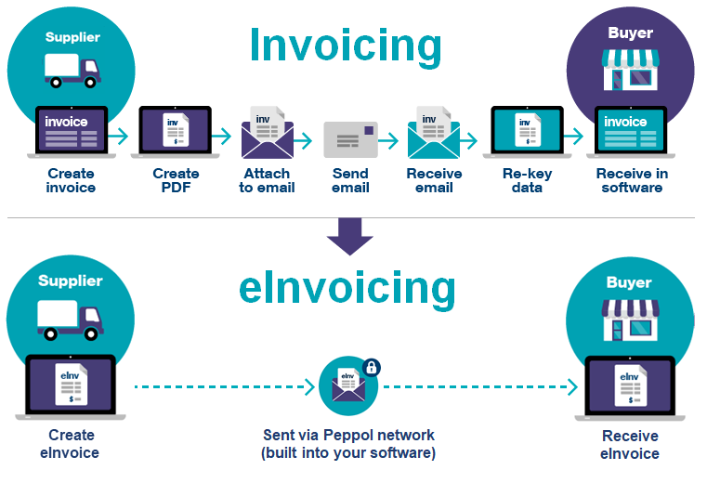

## Benefits of eInvoicing

The benefits of eInvoicing include:

* making invoicing easy by saving you valuable time and effort
* standardised and more accurate invoices, resulting in less mistakes to chase up and correct,
* stronger security compared with posted or emailed invoices, with eInvoices sent through the secure Peppol network
* less chance of invoice fraud or scams
* better business decisions based on correct, real-time financial information
* automated invoicing processes, allowing for increased efficiency and productivity for businesses
* supporting the environment by reducing your consumption of energy, storage space and printing supplies.

## How eInvoicing works

What makes eInvoicing possible is the Peppol standard that allows invoice data to be exchanged between different software or systems.

Australia has adopted Peppol as a common standard for eInvoicing. Peppol is an international framework used in 40 countries around the world, including throughout the EU and New Zealand, Singapore and Japan in our region. As of June 2022, more than 15,000 businesses in Australia are using eInvoicing with more starting every day.

To start eInvoicing, your software needs to be connected to the Peppol network. Many software providers already offer eInvoicing. Accredited eInvoicing products may not refer to Peppol directly but all are using the network. It doesn't matter which software you and your trading partners use to invoice, eInvoicing will work as long as you're both connected to the Peppol network.

In Australia, the ATO is the Peppol authority responsible for ensuring that the eInvoicing standards are implemented consistently by all software providers in the eInvoicing network. The ATO does not receive any information sent through the Peppol network and can not see any eInvoicing data.

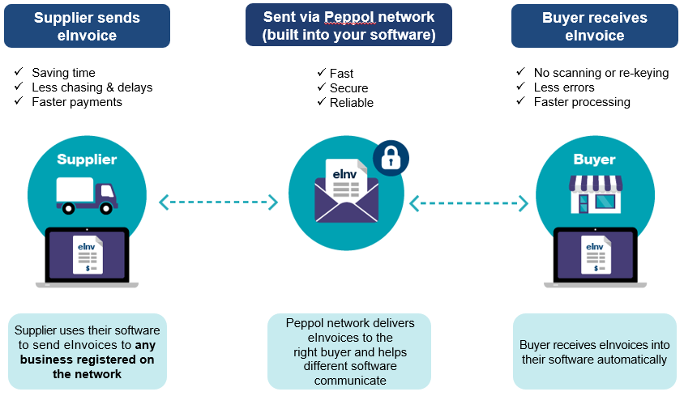

## The ATO’s role

The ATO has been appointed as the Australian Peppol Authority by the Government. In this role the ATO ensures that the eInvoicing standard is implemented consistently by all digital service providers in the eInvoicing network. It also ensures security protocols are followed and organisations participating as access points are trusted entities.

The ATO also promotes the key benefits of eInvoicing for businesses, such as saving time, reducing the risk of fraud and scams, and improving business efficiency and driving adoption throughout the entire economy. By promoting eInvoicing and it’s benefits we are working with Australian businesses to help them become more efficient, more resilient, and better prepared to compete in an increasingly digitised world.

The ATO **does not** receive any invoicing information. eInvoices are transmitted securely through the Peppol network directly to the recipient. Information is not made available to the ATO.

# How to get started with eInvoicing

Getting started with eInvoicing is easier than you think. Depending on how you’re currently creating, sending and processing invoices, there are several options available for you.

## If you’re already using software to create, send or receive invoices

* Check with your software provider to see if they offer eInvoicing. Many Small and Medium Enterprise accounting software providers already have a built-in eInvoicing feature, have plans to introduce it soon or make it available through apps that integrate with your software.
* You can send eInvoices to any business registered on the network - all you need is their ABN.
* To receive eInvoices you will need to register on the network. You can do this through [eInvoicing ready](https://softwaredevelopers.ato.gov.au/eInvoicing-Ready-product-register) software.
* As more of your business partners switch to eInvoicing you will see greater benefits.

## If your software doesn’t have eInvoicing capability

* Find out if your software provider is planning to offer eInvoicing.
* If they are not, you may be able to connect your software to the network via a third-party add-on or app.
* Alternaitvely, visit the [eInvoicing-Ready](https://softwaredevelopers.ato.gov.au/eInvoicing-Ready-product-register)product registerto find an eInvoicing provider. The register is regularly updated as new products become available, including low and no-cost eInvoicing options.

## If you don’t use software for your invoicing

* Consider using an eInvoicing web portal. Many service providers offer this option to support businesses that send or receive only a few eInvoices.
* Invest in an eInvoicing software solution and take a step towards your business’s digital future.
* Visit the [eInvoicing-Ready](https://softwaredevelopers.ato.gov.au/eInvoicing-Ready-product-register)product registerto find an eInvoicing provider. The register is regularly updated as new products become available, including low and no-cost eInvoicing options.
* Talk to your accountant, bookkeeper, or other trusted financial and business advisers about what options may be best for you and your business.
* Visit [ato.gov.au/eInvoicing](https://www.ato.gov.au/Business/eInvoicing/?=Redirected_URL) for more information on how to get started.

## 

## What are the costs involved?

For software users, the cost will vary and depend on your software product. eInvoicing may be included in your subscription or offered as an additional feature or app.

For non-software users, there are free and low-cost plans available through eInvoicing service providers such as web portals. Visit the [eInvoicing-Ready](https://softwaredevelopers.ato.gov.au/eInvoicing-Ready-product-register)product registerto find an eInvoicing provider that suits your needs.

Talk to your preferred software or service provider to find out the costs.

# Frequently asked questions (FAQs)

|  |  |
| --- | --- |
| **General** | |
| What is eInvoicing? | eInvoicing is a standardised way to digitally exchange invoices through software connected to the Peppol network. Unlike paper or PDF invoices, eInvoices don’t need to be printed, posted or emailed.  eInvoicing allows you to send and receive digital invoices with other businesses such as your suppliers, contractors, including government, efficiently and securely. It does not apply to business-to-consumer (B2C) transactions. |
| What if a business has low invoice volumes or doesn’t use software | There are no or low-cost options such as eInvoicing web portals for businesses to use eInvoicing, even if they don’t use software or have low invoice volumes.  Refer to the list of [eInvoicing-Ready](https://softwaredevelopers.ato.gov.au/eInvoicing-Ready-product-register) products for no and low-cost options. The register is regularly updated as new products become available. |
| Can eInvoicing be used for overseas suppliers that do not have ABNs? | Yes, eInvoicing can be used to bill overseas customers, as long as they’re connected to the Peppol network.  When selling to an overseas business, instead of an ABN, you’ll need to enter the business identifier used in the country of that trading partner (e.g. New Zealand uses NZBN).  When purchasing from an overseas business, you would use your usual checks and processes to ensure the legitimacy of an invoice received from overseas suppliers.  The Peppol standard supports multiple business identifiers, including country‑specific (e.g. ABN) and international identifiers, e.g. Global Location Numbers (GLNs). |
| Is eInvoicing available for B2C transactions? | No. eInvoicing is currently only available for business-to-business (B2B) and business-to-government (B2G) transactions. |
| Is eInvoicing mandatory for businesses? | eInvoicing is **voluntary**, but businesses should consider adopting now to benefit.  eInvoicing is easy to set up and use. By joining the eInvoicing network you become part of a community of registered eInvoicing participants, allowing you to transact with them and reap the benefits of this fast, easy and secure service.  eInvoicing is available now and many businesses have already adopted it. Some of your trading partners may require that you use eInvoicing when dealing with them.  All Comonowealth Government agencies are required to be eInvoicing enabled by 1 July 2022 making it easier than ever to conduct business with the government. Many state and local governments are also eInvoicing enabled, with the NSW government committed to eInvoicing by 1 January 2022 and the Queensland Government has also announced its commitment to developing eInvoicing capability. |
| How do I get eInvoicing enabled? | To start using eInvoicing, check with your software provider to see if they offer eInvoicing, what available options might suit your needs, and what you need to do to become enabled.  If you do not currently use any accounting software, there are several no and low-cost options available to you. Refer to the list of [eInvoicing-Ready](https://softwaredevelopers.ato.gov.au/eInvoicing-Ready-product-register) products. You may also want to consider investing in software.  Further information is available at [ato.gov.au/eInvoicing](http://www.ato.gov.au/eInvoicing). |
| Is a Peppol eInvoice a valid invoice for tax purposes? | The legal requirements for a valid tax invoice can be found here: [Tax invoices](https://www.ato.gov.au/Business/GST/Tax-invoices/). These requirements apply regardless of the format (paper or digital).  The Peppol eInvoicing standard can be used to issue an invoice that complies with the legal requirements. However, using eInvoicing does not guarantee or enforce compliance, as those requirements vary for different business scenarios.  It is the trading entity's obligation to understand and comply with the legal requirements for a valid tax invoice. |
| **Benefits** | |
| What are the benefits of eInvoicing? | The benefits of eInvoicing include:   * making invoicing easy by saving you valuable time and effort * standardised and more accurate invoices, resulting in less mistakes to chase up and correct, * stronger security compared with posted or emailed invoices, with eInvoices sent through the secure Peppol network * less chance of invoice fraud or scams * better business decisions based on correct, real-time financial information * automated invoicing processes, allowing for increased efficiency and productivity for businesses * supporting the environment by reducing your consumption of energy, storage space and printing supplies. |
| What are the benefits of eInvoicing for accountants and bookkeepers? | eInvoicing is a new, faster, safer and secure channel for you and your clients to send and receive invoices.  eInvoicing can save time and money for you and your clients by automating the invoicing process via a secure network. This will help you to redirect your focus to higher-value client services, such as:   * Improve your clients’ **record keeping**, making it easier for you to help them meet their reporting obligations * Ensure **accurate invoice** data is automatically received so that you and your clients spend less time dealing with errors * **Reduce the risk of fraud and scams** for you and your clients by using the eInvoicing secure network rather than existing email channels.   eInvoicing will help clients run and grow their business more efficiently and save them time and money. |
| How does eInvoicing reduce invoice fraud? | Fraud and business impersonation email scams are a real threat. According to the [ACCC's Scam Watch](https://www.scamwatch.gov.au/news-alerts/payment-redirection-scams-cost-australian-businesses-128-million-in-2020), Australian businesses lost nearly $128 million to business email compromise scams in 2020.  Peppol eInvoicing provides a secure network through the use of business identifiers, message encryption, network security and governance controls.  eInvoicing also promotes good supplier onboarding and verification processes for receivers through governance controls.  eInvoicing uses structured data (a digital template) and a secure network. This is far more secure than an unsecured PDF sent via email. Doctored PDFs are responsible for a large number of invoice fraud (e.g. snipping another bank account into the PDF).  While the risk of fraud is significantly reduced, eInvoicing does not eliminate all risk. You still need to apply your internal checks and assurance processes before paying your invoices. Your software may help you with automating some of these checks (e.g. ABN checks, matching back accounts against information you already hold about a supplier account). |
| **What is the ATO’s role?** | |
| What is the role of the ATO in eInvoicing and can it see eInvoice data? | The ATO has been appointed as the Australian Peppol Authority by the Government. In this role, the ATO ensures that the eInvoicing standard is implemented consistently by all digital service providers in the eInvoicing network and also ensures security protocols are followed and organisations participating as access points are trusted entities.  The ATO also promotes the key benefits of eInvoicing for businesses, such as saving time, reducing the risk of fraud and scams, and improving business efficiency.  The ATO **does not** receive any invoice information. eInvoices are transmitted securely through the Peppol network directly to the recipient. Information is not made available to the ATO. |
| **Costs** | |
| How much does it cost to adopt eInvoicing? | Most small business accounting software providers are building eInvoicing features into their existing products and some already have it available.  This may include free or low-cost options such as web portals depending on how many invoices you exchange and your product.  Talk to your preferred software or service provider to find out their costs.  See the [eInvoicing-Ready](https://softwaredevelopers.ato.gov.au/eInvoicing-Ready-product-register) registerto find a low/no-cost option if you don’t use software. |
| **How does eInvoicing work?** | |
| How does eInvoicing work? | What makes eInvoicing possible is the Peppol framework. It includes specifications that standardise invoice data, a delivery network and a system of legal agreements.  All software must use the Peppol standard to send and receive eInvoices. To start eInvoicing, your software needs to be connected to the Peppol network.  It doesn't matter which software you and your trading partners use to eInvoice, as long as you're both connected to the Peppol network. |
| When will eInvoicing be available in accounting software? | Many major software providers already offer eInvoicing options, and more will be offering it soon.  Contact your software provider to find out if they offer eInvoicing or if they intend to make it available soon. You can also check out the ATO [eInvoicing-Ready register](https://business.gov.au/finance/payments-and-invoicing/e-invoicing). |
| How do I know if a business is registered for eInvoicing? | Businesses that can receive an eInvoice can be found by searching the [Peppol Directory](https://directory.peppol.eu/). Your software will check if the business is able to receive eInvoices before sending an eInvoice to them. |

# Sample articles

## eInvoicing can save you time and money

eInvoicing streamlines the exchange and processing of invoices, with invoices automatically appearing in your software. It removes the need for manual entry, reduces errors, limits missing and incorrect information and eliminates lost invoices.

Peppol eInvoicing is a common eInvoicing standard in Australia. With Peppol, invoices are sent directly to your trading partner’s software using their ABN, so the right information gets to the right contact in seconds.

eInvoicing is becoming increasingly available through software products and is inexpensive, so getting started is easy. With eInvoicing, you can save time, get paid faster and make business decisions based on accurate and real-time financial information.

Check out [[ato.gov.au/eInvoicing](https://www.ato.gov.au/Business/eInvoicing/?=Redirected_URL)](https://business.gov.au/finance/payments-and-invoicing/e-invoicing) for details on how to get started with eInvoicing.

## eInvoicing – the safe and secure way to do business

Scams and fraudulent and unsolicited invoices are a challenge for businesses. According to the [ACCC's Scam Watch](https://www.scamwatch.gov.au/news-alerts/payment-redirection-scams-cost-australian-businesses-128-million-in-2020), Australian businesses lost nearly $128 million to business email compromise scams in 2020.

Email is often used for billing scams, such as business impersonation scams and phishing attacks. Email allows cyber criminals to defraud you of your hard-earned cash and gain access to your business data and systems. The consequences of such attacks could be dire, costing you time, money, and potentially damaging your business, reputation and relationships.

eInvoicing is a more secure way to send and receive invoices than email. It relies on message encryption, network security and governance controls. By using eInvoicing to exchange invoice data directly through your software, you’ll minimise the risk of invoice fraud or scams.

Check out [ato.gov.au/eInvoicing](https://www.ato.gov.au/Business/eInvoicing/?=Redirected_URL) for details on how to get started with eInvoicing.

## eInvoicing – the new way to invoice

eInvoicing is the new, fast and easy way to send and receive invoices in your software. It is not email and PDF.

The benefits of eInvoicing include:

* time and cost savings by reducing manual data entry, as invoices appear in your software, ready to be paid
* not having to fix errors, chase missing information or lost invoices
* getting paid faster and improving your cash flow
* reducing the risk of scams and fraud
* supporting the environment by reducing your consumption of energy, storage space and printing supplies.

eInvoices are transmitted securely by ATO-approved service providers. Although the ATO administers the network, they can’t access or view your invoices.

You can only send eInvoices to businesses registered on the eInvoicing network. Let your trading partners know you're registered and encourage them to get started so you can all reap the benefits.

Talk to your preferred software provider or trusted adviser about how to get started with eInvoicing. You can also view the [eInvoicing-Ready](https://softwaredevelopers.ato.gov.au/eInvhttps:/softwaredevelopers.ato.gov.au/eInvoicing-Ready-product-registeroicing-Ready-product-register) product list that includes free or low-cost options if you only need to send a small number of invoices.

Check out [[ato.gov.au/eInvoicing](https://www.ato.gov.au/Business/eInvoicing/?=Redirected_URL)](https://business.gov.au/finance/payments-and-invoicing/e-invoicing) for more information about eInvoicing.

# Sample onboarding email

To take advantage of the benefits of your eInvoicing capability, it’s important to start engaging with your trading partners as soon as possible.

The changes to your invoicing processes will impact your trading partners and you need to allow enough time for them to get ready. We recommend informing them that you’re planning to become enabled and again once it’s been implementented.

The following email can be tailored by you for your audience – please edit the material in *italics* as appropriate. Feel free to add more information from this kit such as the benefits, FAQs or images.

**Subject:** *Option 1:* Get ready to eInvoice with us *Option 2:* We are eInvoicing-enabled!

**Body:**

eInvoicing is a significant step toward a digital economy that will improve efficiency and digital experience of our trading partners.

*[business name]* *[is implementing/has implemented]* eInvoicing to make this new electronic channel available to our suppliers and customers. *(If desired, include detail on why you have made this business decision and timing.)*

To start eInvoicing with us and unlock the benefits of eInvoicing for yourself, you’ll need to be eInvoicing enabled too.

What is eInvoicing?

eInvoicing is the standardised digital exchange of invoice information directly between a buyer’s and supplier’s software.

eInvoicing supports faster processing of invoices and therefore faster payments. Invoices can also be sent and received in a more secure way than emailing PDFs or other traditional methods.

eInvoicing uses a new standard adopted by the Australian Government, called Peppol. As the agreed common standard, Peppol works as a language that any software can understand once it’s enabled. The Peppol standard is open, and over time will become a commonly used, low-cost channel for exchanging business documents.

To find out more about eInvoicing visit [ato.gov.au/eInvoicing](https://www.ato.gov.au/Business/eInvoicing/?=Redirected_URL).

How you can start eInvoicing

*Option 1: if trading partner is already using software*

To start using eInvoicing, you’ll need to check with your software provider to see if they offer eInvoicing and what you need to do to get started.

*Option 2: if trading partners isn’t using software*

If you don’t currently use software to create or manage invoices, or if you only send a small number of invoices, there are a range of free and low-cost products available. You can also talk to a trusted business adviser about what options that might be right for you.

View the ATO’s [eInvoicing-Ready](https://softwaredevelopers.ato.gov.au/eInvoicing-Ready-product-register) product register to find eInvoicing-Ready software products.

We will keep you informed about our progress. If you have any questions, please contact *[insert contact details].*

# Social media messages

* eInvoicing is here! No more manual data entry and chasing missing information or lost invoices. With eInvoicing you can automatically send and receive invoices through your accounting software. This will save you time, money, and stress. To find out how to get started with eInvoicing, visit [[ato.gov.au/eInvoicing](https://www.ato.gov.au/Business/eInvoicing/?=Redirected_URL)](https://business.gov.au/finance/payments-and-invoicing/e-invoicing).
* Sick of wasting valuable time managing invoices? eInvoicing is the new, fast, easy and secure way to automatically send and receive invoices. It’s easy to get started. To find out how, visit [ato.gov.au/eInvoicing](https://www.ato.gov.au/Business/eInvoicing/?=Redirected_URL).
* Spend less time doing paperwork and more time growing and running your business with eInvoicing. Send and receive invoices automatically, securely, and quickly in your software. No more PDFs, email and falling victim to billing scams. To learn more about eInvoicing, visit [ato.gov.au/eInvoicing](https://www.ato.gov.au/Business/eInvoicing/?=Redirected_URL).
* eInvoicing will save you time and money. Send invoices directly into your customers’ software and receive your supplier invoices straight into your own software without the hassle of manual data entry. Don’t be left behind, get started today. To learn more about eInvoicing, visit [ato.gov.au/eInvoicing](https://www.ato.gov.au/Business/eInvoicing/?=Redirected_URL).
* eInvoicing works with a wide range of software to help you send and receive invoices quickly and safely. Get started today. To learn more about eInvoicing, visit [ato.gov.au/eInvoicing](https://www.ato.gov.au/Business/eInvoicing/?=Redirected_URL).
* eInvoicing, powered by the Peppol network, is the new, fast, easy and secure way to send and receive invoices. Exchanging invoices directly through software can help you cut out manual processing and the delays associated with paper and PDF invoices. Talk to your software provider today about how you can get started.
* <*insert business name*> is now eInvoicing-enabled! To exchange eInvoices with us, and unlock the benefits of eInvoicing for yourself get started now. To find out how, visit [ato.gov.au/eInvoicing](https://www.ato.gov.au/Business/E-invoicing/Benefits-of-e-invoicing/).
* Say goodbye to email and billing scams, switch to eInvoicing. To find out how, visit [ato.gov.au/eInvoicing](https://www.ato.gov.au/Business/eInvoicing/?=Redirected_URL).

# Images

These images are available in the following formats:

* Facebook: 1080x1080
* LinkedIn: 1200x628
* Twitter: 1200x675

